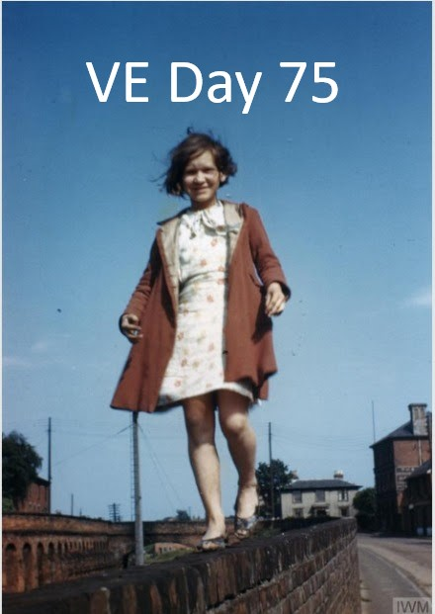
Earlier this year preparations were being made for the commemoration of the 75th anniversary of VE Day, unfortunately the COVID-19 pandemic has put paid to the planned events. As part of the preparations I was given access to the records of The Welcome Fund held by Wivenhoe Town Council, I wasn't previously aware of their existence so was in for a bit of a surprise.
The Welcome Home Fund was set up during the war by Wivenhoe Urban District Council as an expression of gratitude to the men and women of the village who served in all branches of the services during the war. It was distributed in the summer of 1946 (when some recipients were still serving overseas) and came in the form of saving certificates, each person also received a Certificate of Appreciation.
The records themselves offer a unique insight into Wivenhoe during WWII and comprise of account and minute books, correspondence as well as approximately 250 Welcome Home slips. These slips record every person who was eligible for a share of the fund and as such virtually every person from Wivenhoe who served during the War.
Although the list shown here is thought to include every person who was resident before the war a number of those who served settled here after it. Wivenhoe House was used as an Army base during the war and was home to a number of regiments including Tank regiments early on and 2nd Battalion SAS in the latter stages of the war. A number of former servicemen who were stationed at Wivenhoe House made Wivenhoe their home and two are added here, both Majors in the 2nd SAS and both commemorated in the New Cemetery.
Dedicated to the memory of all those who served.
Michael Smither
Wivenhoe, 7 May 2020.

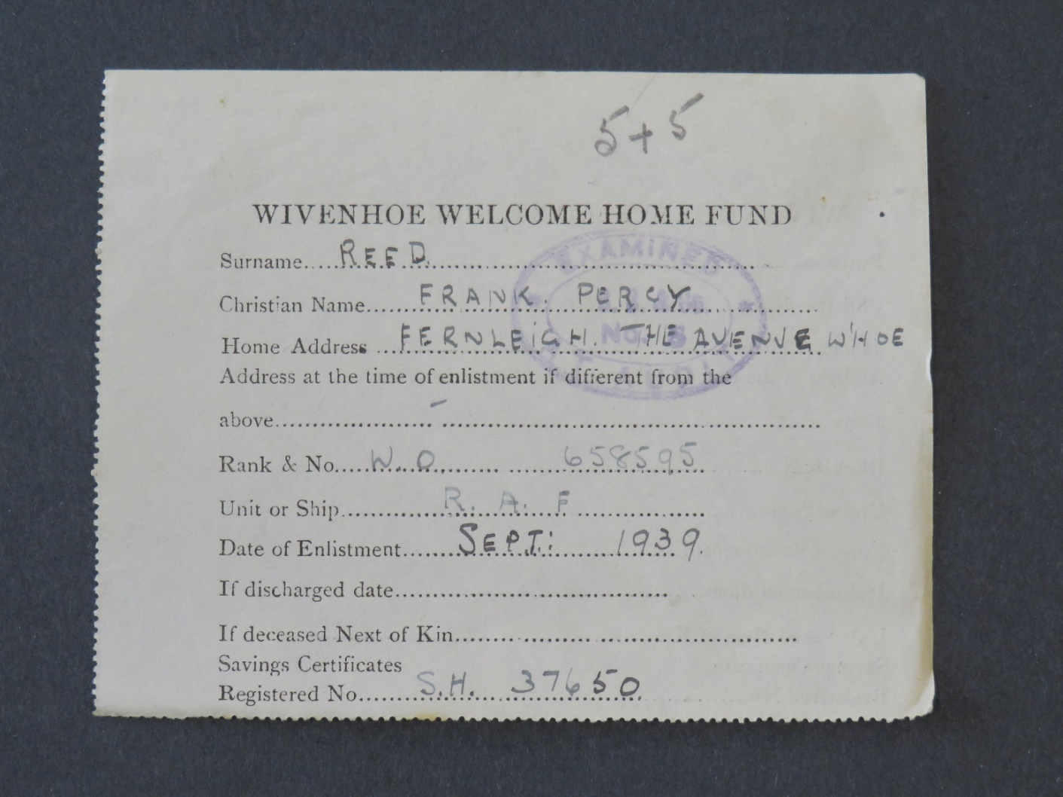
Welcome Home slip for Warrant Officer Frank Percy Reed, one of many to enlist at the start of the War.
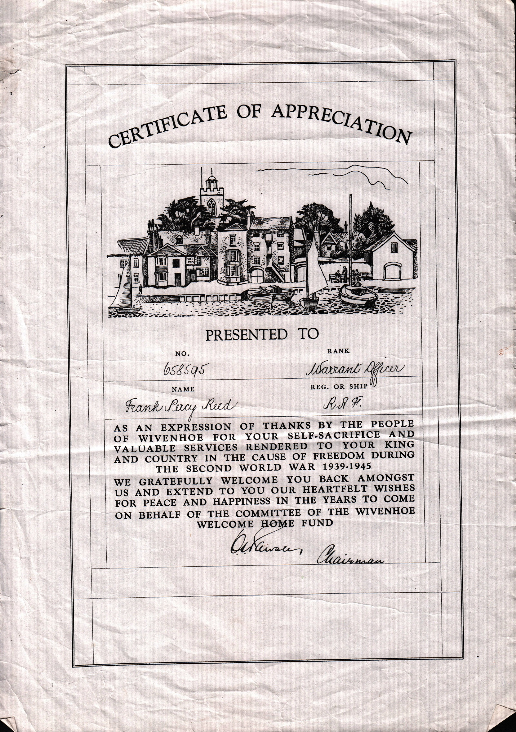
Certificate of Appreciation for Warrant Officer Frank Percy Reed

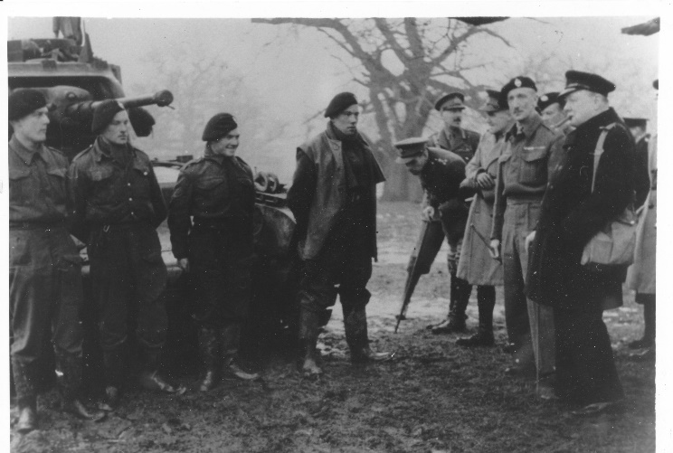
Churchill at Wivenhoe. Wivenhoe House was home to a number of Regiments during the War, most famously the 2nd Battalion SAS in its latter stages. This picture is undated, but earlier, when one of the Tank Regiments was there, the Tank is a Matilda.
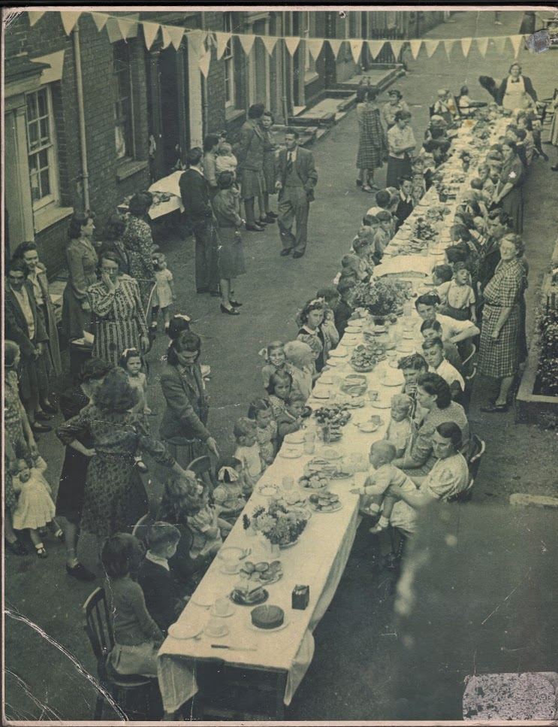
VE Day Street Party, Alma Street
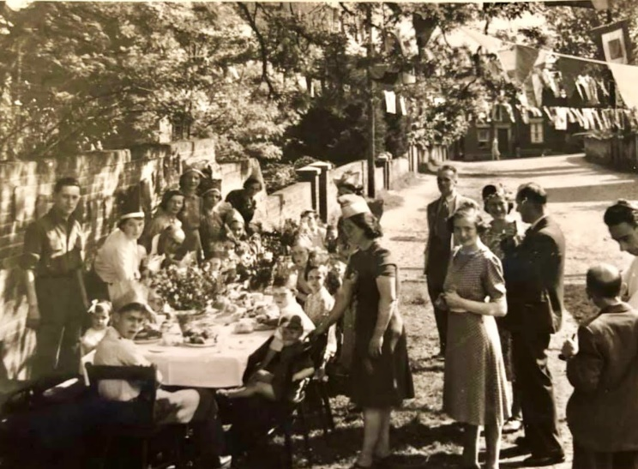
VE Day, Park Road (looking South) Rev Gosney bottom right.
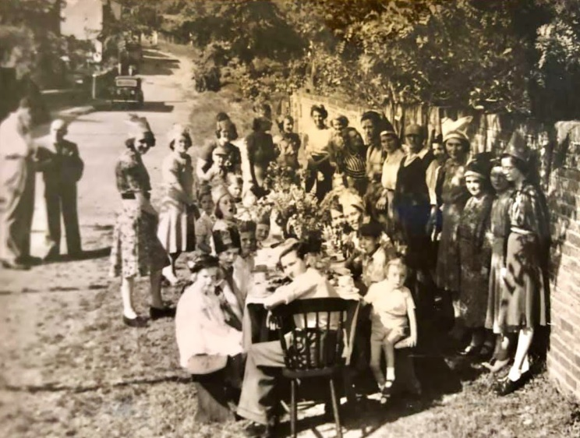
VE Day Street Party, Park Road (looking north) Rev Gosney standing second left.
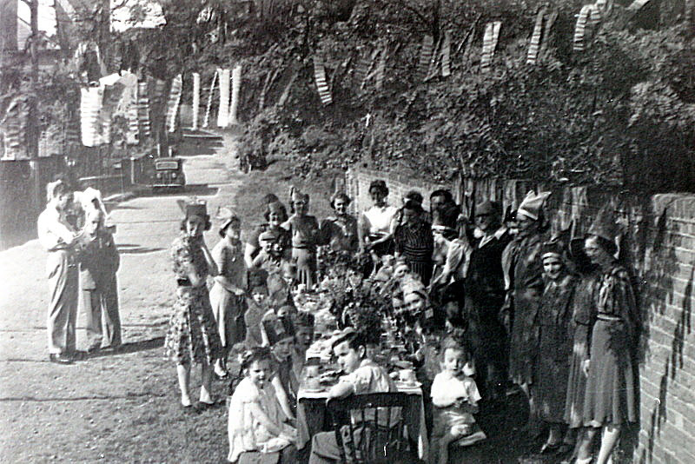
Slightly different version of the above.
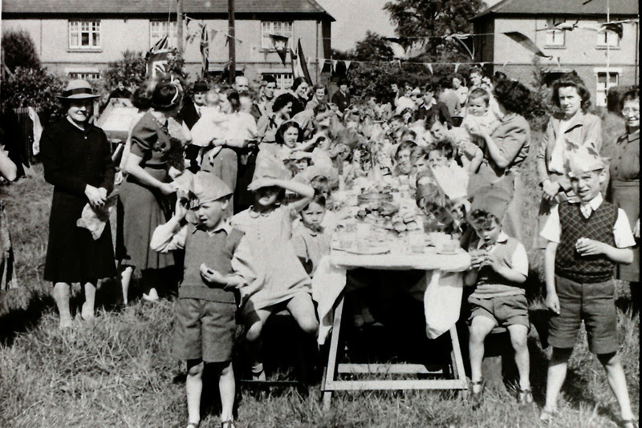
VE Day Street Party, Rectory Road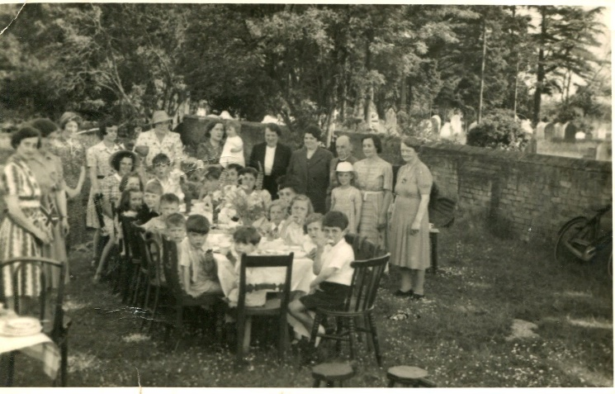
VE Day Street Party, Belle Vue Road, Old Cemetery in the background.
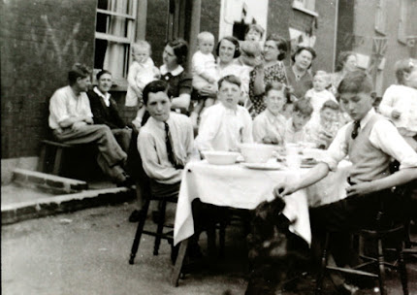
VE Day Street Party, Paget Road, note V for Victory graffiti on the wall, top left.
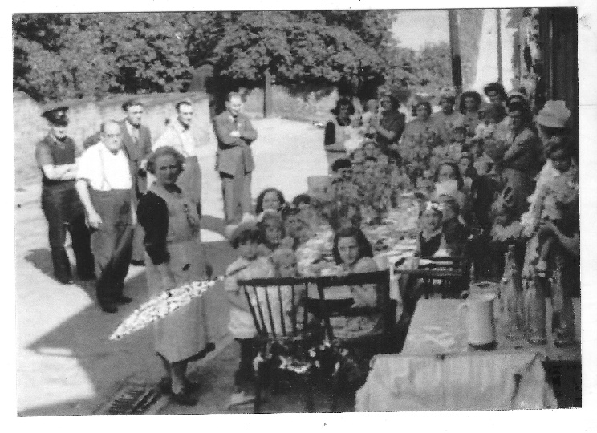
VE Day Street Party, Queens Road
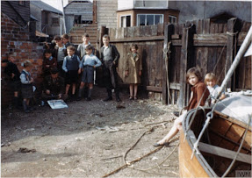
Sailing Club Yard, Anchor Hill, 19 May 1945, USAF Airman with local children. First day of boating since the start of the War, image by Robert Sand, 55th Fighter Group, USAF. The girl in the red coat is also shown in the first photograph, walking down the Station Road wall. Possibly the earliest colour photographs of Wivenhoe.
ABLITT, Dennis Arthur AB TX283896 HMS Pursuer (1925-1998) Gable Villa, Hamilton Road.
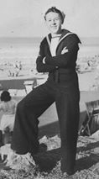
AGER, Stanley LC 6023970 CM Police (1913-1989) Oakville, Wivenhoe Cross.
ALLSOPP, Vera Maud Pte W/100026 ATS (1904-1987) West Street.
ATKINSON, John Simmons LAC 1466025 RAF (1921-1994) The Avenue.
BAILEY, John Charles Sapper 1876966 Royal Engineers (1923-1991) High Street.
BAILEY, Maurice Guy Capt 237216 Royal Artillery (1916-1989) Manor Road and “Seaton”, Rectory Road.
BARNARD, Mary Ellis (nee GOODWIN) Third Officer 19438 WRNS (1921-2010) Winifred House, High Street, Wivenhoe.
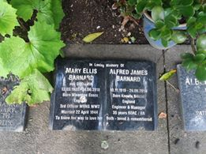
Auckland, New Zealand
BARNES, James A. Chief Officer F Wheelsman
BARNES , William Daniel James L/Cpl 13030818 Corps Military Police (1919-1997) Station Road.
BARR, Doris Ellen Pte 140479 RAOC ATS (1925- ?)
BARR, Kathleen Dora Pte KD 140478 RA ATS (1926-?)
BARRETT, Alfred George (1908-1976) Anchor Hill
BARTLETT, Alan H T 14868946 Cpl Essex Regiment Att B Coy. (1928-)
BARTLETT, Alfred C (1909-1978)
BARTLETT, Charles Henry Purser, TSS Port Adelaide (1904-1947). Alma St
BARTON, Leonard Pt 14955304 RASC (1911-1981). Hamilton Villa, Hamilton Rd
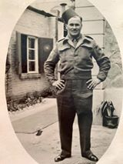
BARTON, Ronald Sgt 905204 RAF(1918-2002) 3 Station Rd
BATES, James Charles Cpl 1196908 SHQ Hendon (1910-1962). Fern Cottage, Queens Rd
BEESON, Herbert Maurice Cpl REME (1917-1957). Abbotsford, Park Rd and Morant Rd, Colchester.
BELL, Arthur Edward AB S 12365 Falconet General (1917-1965) The Folly.
BELL, Isaac Francis LAC 964767 RAF (1915-1993) Alma St.
BELL, James Alfred Douglas Sgt 13035034 Pioneer Corps (1915-1974) Blyth Lane
BELL, John Thomas L/Cpl 5672219 102 Provost Camp GMP (1891-?)
BELL, Robert Wallas Sgt 7633644 RASC (1920-?)
BELLAMY, Violet Rosaleen Mary Cpl W/162285 ATS (1920-2014) Chatenay, The Avenue.
BELLMAN, Cyril 863722 L/Sgt 89 A/T Regt RA (1918-1974)Paget Rd and West St.
BIRKIN, Albert RN HMS Nelson (1920-1980)The Cross
BISSELL, Eunice Doreen Wren 90668 HMS Kestrel (1921-?)
BLOOM, George Cpl 1150536 RAF 185 Wing H2 (1916-1993) Station Rd.
BONES, Jack Royal Marines EX 4365 (1917-1997) St Norbert Rd, Brockley SE and Colchester Rd, Wivenhoe.
BOSANQUET, Richard BQMS 5764044 Essex Yeomanry RHA (1901-1981) Ernest Rd
BOWES, Robert Walter Pte 14797255 2nd Lincolns (1926-2000) Ballast Quay Farm
BROWN, Cyril J LAC 1047075 RAF (1911-?) Hazeldene, High St.
BULL, Robert L/Sig JX371301 Royal Navy (1926-?) Manor Rd
BULL, Ronald
BURT, Tom, MBE Major 2nd Btn SAS
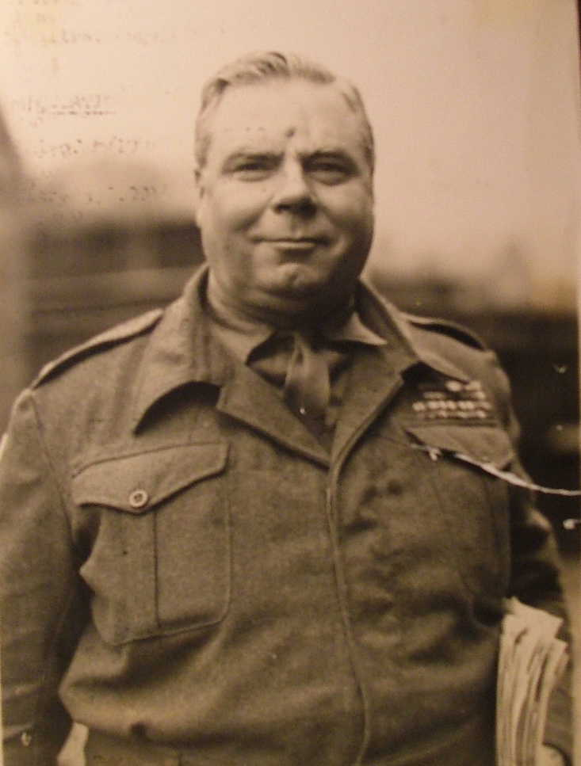
Major Tom Burt MBE TD
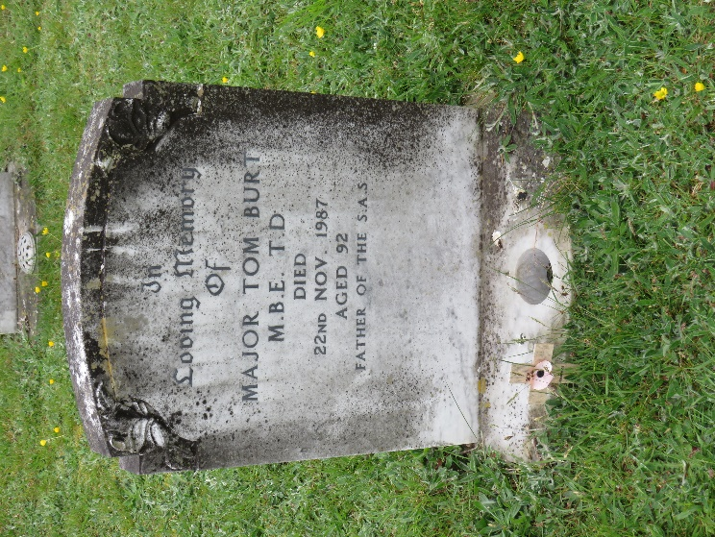
Major Tom Burt’s headstone, Wivenhoe New Cemetery
BUTCHER, William Ernest Flight Mec II RAF VR 1441315 A Squadron Wing (?-?)Hamilton Rd
BUTT, William Michael (1902-1975) Brook St.
CADOGAN, John Sgt 1845981 Royal Engineers (1921-?) Lodge Farm Cottage
CANDLER, Arthur Private 1441720 (1925-2011) West St
CANDLER, James Bramwell L/Cpl T/71303 RASC (1917-1983) West St
CANDLER, Richard John Sgt D/32463 RAMC (1904-1976) Malting Yard
CANDLER, Victor Dvr T/956278 RASC (1919-1992) West St
CARLTON, Wilfred (1924-1947)
CAULTON, Eric (1911-1992) Rose Cottage, Plough Corner, Little Clacton
CELIS, Edward John Pte 7343726 RAMC
CHAMBERLAIN, Jack Charles. S/Ldr RAF 31427 (1917-2009) Ivydene, Queens Rd
CHANEY, Allan Percy Corporal 1252003 RAF Air Sea Rescue (1912-2003) The Avenue
CHILD, Robert Gunner 1505981 HY AA RA (1918-?)
CLARK, Walter Charles (1920-1999)
CLARK, William Raymond Trooper (1918-2006) Westcott, High St
CLARKE, Eleanor
CLARKE, Frederick John Lacconee (1901-1985)
CLARKE, Harold Victor Cpl 63279 RAF (1898-1960) 11 Manor Rd.
CLARKE, Muriel Cpl No W/89543 ATS 163 OCTU
CLARKE, Robert Owen 2nd Lieut 6854342 Royal Fusiliers
CLENCH, John Royal Navy
COATES , John Lloyd Fusilier 3445727, 2nd Batt The Lancashire Fusiliers (1913-2003) Grove Cottage, Elmstead Road
COE, Edna Jean, Civilian (Munitions Worker) died 3 Apr 1943, North Stafford Royal Infirmary, age 18. Buried Wivenhoe New Cemetery (plot F79) commemorated Wivenhoe War Memorial.
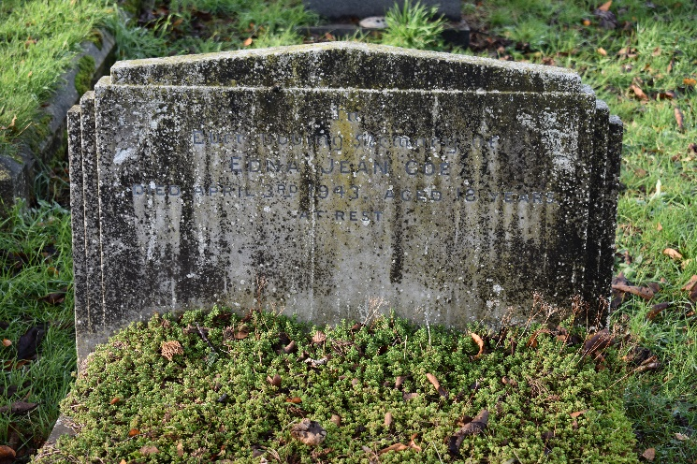
Edna Jean Coe’s headstone, Wivenhoe New Cemetery
COOK, Harry George Derrick Pte 4749801 8th Royal Scots (1917-2008) Manor Rd
COOPER, Frederick William RAOC
COX, Enid W/139047 ATS (1919-?)
CRASKE, Leslie Corporal 1177992 RAF (1916-2001) Westow, The Avenue
CROSS, Elaine Cook 52195 WRNS Pembroke (1923-2017) Colne Terrace, Park Road
CROSS, Robert J Artificer (PO) MX 73990 HMS Superb (1925- )
CUDMORE, Georgette Edith Pte W/209503 (1922-1961) Rectory Road
DADDS, Frederick John Sapper 2129908 RE (1908-1994) West St
DAN, Philip Frederick HMS Chinkara (1926-1990) Ernest Rd
DANN, David B R 3059570 RAF (1927-1991) Beechcroft, The Avenue
DAVIES, Geoffrey Charles 7596816 St/Sgt RAOC REME (1910-?) Grosvenor Hotel
DAY, Peter Leonard N A 2 FAA/FX 705771 Fleet Air Arm (1926-2006) Rectory Rd
DENHAM, Arthur 408572 RAF (1892-1964) Queens Rd
DENHAM, Owen Stewart Sub Lieut HMS Lock Elk (1921-1996)
DENYER, George Harford 14756510 DCLI (1926-2001) St Ives, Alresford Rd
DENYER, Lyndon Stanley *2954 RAF (1923-2013) St Ives, Alresford Rd
DENYER, Peggy Eileen W/2000131 WAAF (1924-2014) St Ives, Alresford Rd
DIGGINS, Arthur P/Mx635932 Royal Navy (1920-2005)
DOWNS, Frank Stanley 14288877 RAOC (1904-1977) Anchor Hill
DRINKELL, William George Flight Lieut Transport Command (1893-1978) Melbourne, Ernest Rd
DUNNE, John James 1612101 RAF (1922-2004) Oaklands
DUNNE, Richard Edward 1st Off Elder Dempster Lines (1921-1985) Oaklands
DURRELL, Richard John HMS Nemo (1912-1974) 22 Rectory Rd
EDWARDS, Doris Evelyn 469345 WAAF
ELLIS, Albert Charles MX/77331 HMS Zenith (1920-?)
EVANS, Lewellyn James Lt St. George
FAUCHEUX, Philippe George 1231133 RAF (1925-2013)
FENNEL, Arthur William (1923-1992) The Gables, Anchor Hill
FIRMAN, Arthur Charles 1201031 RAF (1912-?) High St
FISHWICH, Abraham Lt/Jx19590 HMS Bym?
FISK, Douglas 14810275 Lincolns (1926-1990) Alma St
FISK, Edgar Philip 929587 RAF (1908-1980) Rectory Rd
FISK, Ivan 1837163 RA (1913-2006) Hadlow Rd, Tonbridge, Kent
FLEMING, John Wilson, HM Submarine Seahorse, RN KIA 12 Jan 1940. No known grave, commemorated Portsmouth Naval Memorial and Wivenhoe War Memorial.
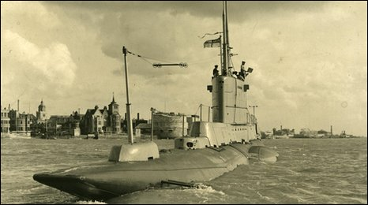
HM Submarine Seahorse leaving Portsmouth.
FORSTER, Charles 167661 MN (1922- ?)
FROST, Ronald Victor T894713 RASC
FRY, Charles James 140109 RASC (1907-1995) Quay House
GARRARD, Harold AB MN (1917-1983) Station Rd
GARRARD, Nelson 1721052 RA (1908-1989) Station Rd
GIBSON, Douglas Harold 9545 RA (1920-2006) 7 Knox Road, Clacton
GIBSON, Octavius William 1547317 RA (1906-1985) Fernside, Belle Vue Rd
GLADDEN, Jack R294399 MN (1922-2002) East St
GLADWIN, Arthur William James 952547 RAF (1914-2002) Quay St
GOLDSTRAW, Marjorie W/139048 ATS (1921-2010)
GOODALL, Andrew Frank Charles Pte RTC (1920-2012) Bath St
GOODALL, Doreen Phylis May W2009548 WAAF (1924-?)
GOODALL, Ronald Frederic C/JX 155737 HMML 849
GOODWIN, Barbara Winifred W/*** 5652 WAAF (1915-1985) Lynton, Belle Vue Rd
GOODWIN, George Edward 950068 RA (1919-1987) Colne Terrace, Park Rd
GOODWIN, Walter William Ernest 2369700 Royal Signals (1905-1984) Colne Terrace
GOODY, Frederick Charles 1423671 RA (1916-1982) Ernest Rd
GORE, John Stephen 2100338 RA (1916-1997) All Saints Av, Colchester
GOULD, Leonard Thomas C/MX86421 HMS Pickle (1925-1993) Cornwall Villas
GREEN, Alec 14356793 RASC (1905-1980) Rosedene, Paget Rd
GREEN, Alexander 7342150 Black Watch.
GREEN, Eric Albert Maudsley 234187 Signals (1915-1997) 5 Manor Rd
GREEN, Jack Edwin 1335503, 313 (Czech) Sqdn RAF Volunteer Reserve died 12 Sep 1943, age 21. Buried Wivenhoe New Cemetery (plot F105) commemorated Wivenhoe War Memorial.
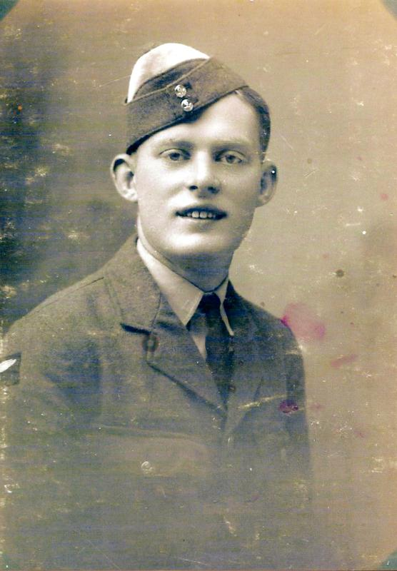
Flight Sergeant Pilot Jack Edwin Green
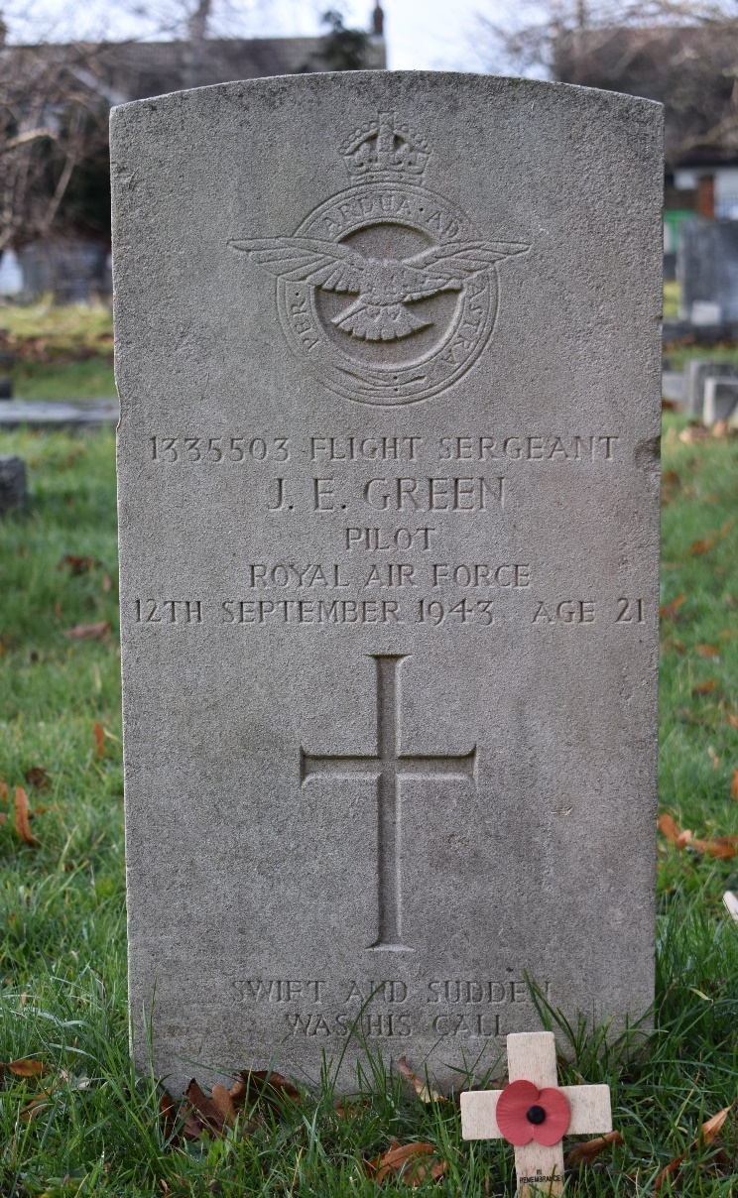
Flight Sergeant Green’s Headstone, Wivenhoe New Cemetery.
GRIGGS, George RK6012432 Essex
GUNN, John Seaman Epping (1904-?) West St
HAMMOND, Jack Hardy 6022248 Essex Regt (1917-?)
HARRIS, Walter Charlie 6092526
HART, Hugh Thomas 14396677 Signals (1915-2009) Claremount Villas, The Avenue
HARVEY, Edward Thomas CJY188465 HMS Vengeance (1924-2000) Rectory Rd
HARVEY, James William 1218323 RAF (1922-1995) Rectory Rd
HATCH, Harry Thomas 6019725 Essex Regt (1917-2005) Manor Rd
HATCH, Jack 1616254 RA (1913-1993) Manor Rd
HATCH, Robert William 1602392 RA (LAA) (1917-1997) Alma St
HEADLAM, Anthony John 513064 RAF (Gosport) (1912-1987) Northcroft Rd, Gosport, Hants
HEADLAM, Betty Louise 513064 WAAF (1921-2013) Claremount Villa
HEATH, Eileen W/86070 Wrens
HEPPENSTALL, Willie 3445716 Military Police (1914-1988) Colchester Rd
HERBERT, Gordon 904402 RAF
HERBERT, Kenneth 1446779 RAF
HEWETT, George James 734578 RAMC (1916-1985) Rectory Rd
HODGES, Kenneth Morrell 1427145 RAF (1920-2003) Elmcroft, The Avenue
HODGES, Norman Edward 958457 RAF (1916-1965) Papillon Rd
HODGSON, Wilfred 7388728 RAMC (1916-?)
HOLDEN, Grace W/162287 ATS (1918-1999) The Cross
HOLLOWAY, Margaret Winifred W/224771 ATS (1911-2005) High St
HUNTER, George PJX/543782 HMS Collingwood (1912-?) Rectory Road
HURLEY, John, JX/371603 HMLST 373 (1926-1955)
INGATE, Harold Frank 13047828 Pioneer Corp (1912-1996) Fernbank, High St
INGATE, Walter 6014378 ACC (1910-1979) High St
JACKSON, Percy Edward 602996 Essex Regt (1902-1979) Bramwell House Ernest Rd
JAMES, Nellie Mary W3536051 VAD (1902-1990) The Grove
JEFFREY, Leslie A V T125402 RASC (1909-?) West St
JOHNSON, Henry 129590 Mess Dept. Chatham (1910-1990) Elmstead Rd, The Cross
KETTLE, Herbert Ernest 6028482 Commandos (1922-?)
KETTLE, Herbert James 683739 RAMC (1893-1963) Alma St
KIBBLE, William Charles 7908166, 7th Queen’s Own Hussars, Royal Armoured Corps KIA 10 June 1942. Buried Ranchi War Cemetery, Jharkhand, India.
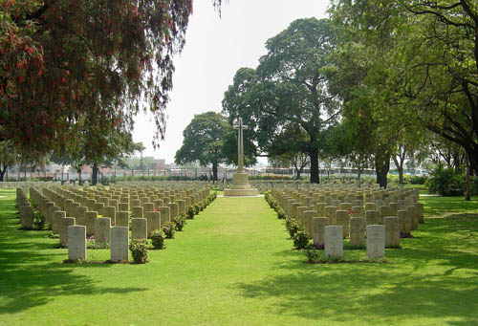
Ranchi War Cemetery.
KINCH, George William 1187143 RAF 1914-1964 Ronald Ave E6
KING, Peggy Iris W/236337 ATS (1920-2000) High St
KNAPPETT, Ernest 2124362 Royal Engineers (1910-1994) Brook St
KNAPPETT, James Sidney 6456548 (1908-1973) Brook St
LACH-SZYRMA, Dudley William Somerville T3176931 (1892-1974) Anchorage, Wivenhoe Cross
LEE, Doris Evelyn W/446951 WAAF (1920-2004)
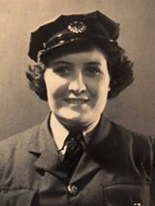
Trehaven, Rectory Rd
LEE, William George 640164 RAF (1919-2004) Trehaven, Rectory Rd
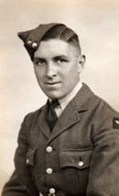
LENNOX, James CJ350779 Chatham (1924-?)
LINNETT, Arthur 6087276 Queens Royal (1920-?)
LOVELESS, Donald William P/M732547 HMS Nairana (1926-1996) River View, Alresford Rd
LOVELESS, Raymond Cecil FX588167 HMS Implacable (1924-1986) River View, Alresford Rd
LOVELESS, William Harry 292598 Reconnaissance Corps (1921-2015)
MARTIN, Dorothy W/2009777 WAAF Colne House, Station Rd
MARTIN, Robert KX144414 HMS Stockham (1924-?) Colne House, Station Rd
MARTIN, Robert Dixson 6031316 Royal Engineers (1900-1979) Colne House, Station Rd
MASON, Donald Arthur William KX119137 HMS Northney (1906-1985) Park Hotel
MASON, Jean Margaret W/2009916 WAAF
MAWDSLEY, Basil Edward CJ390339 HMS Swiftsure (1925-2000) Shipwrights Arms
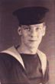
MAWDSLEY, Dorothy 139419 ATS Shipwrights Arms
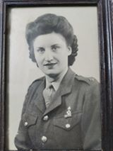

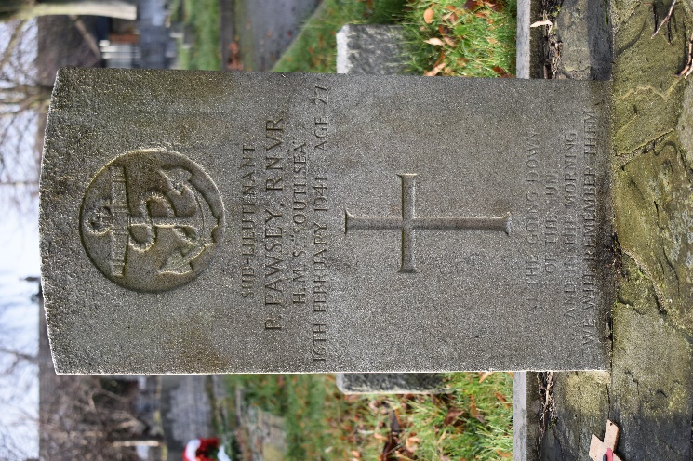
MAWDSLEY, Ralph Noel 828543 RA (1917-2013) Quay Cottage
MEAD, John Colin 6101515 Queens Royal Regiment
MILLER, Donald Ernest 1473018 RAF (1921-2003) Sand Hurst, Keelars Lane
MILLER, Leonard George 1645577 RAF (1924-1977) Sand Hurst, Keelars Lane
MORRIS, Robert Joseph 13033596 Pioneer Corps (1915-1990) Anchor Hill
MOSS, Ralph 80420 REME (Indian Army)
MULLINS, Walter T/14986 (was POW) (1916-1971) Park Rd
PARKER, Guy Kenneth FX100795 HMS Nabsford (1922-2006) Wivenhoe Cross
PARKER, Jean W/2009682 WAAF
PARKER, Robert W H 80410 REME
PARRY, George A 1101836 RAF (1916-2007) Springfield, The Avenue
PARRY, George T Gnr Com Transylvania (1883-1965) Springfield, The Avenue
PASCOE , Jack Hazell 1331757 RAF (1922-2012)
PASCOE, Leslie George, P/JX 317494 HMS Southern Flower, RN, KIA 3 Mar 1945. No known grave, commemorated Portsmouth Naval Memorial and Wivenhoe War Memorial.
PASCOE , Philip James LT JX281391 (1904-1991) Oswald House, The Avenue
PAWSEY, Peter, Sub Lieutenant RNVR HMS Southsea, KIA 16 Feb 1941. Buried Wivenhoe New Cemetery (plot F51) commemorated Wivenhoe War Memorial

Sub Lieutenant Pawsey’s headstone, Wivenhoe New Cemetery.
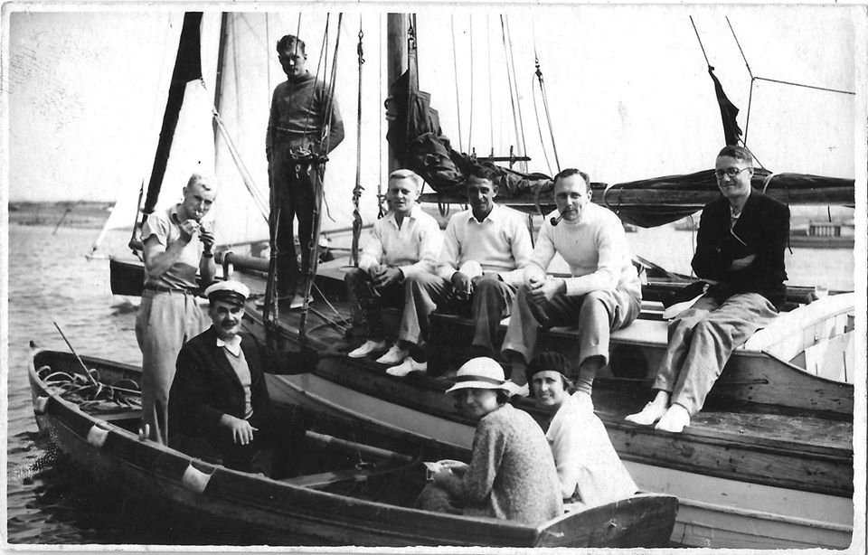
Peter Pawsey (standing, far left) pictured in 1935
PAYNE, Frederick LT/203693 Europa (1916-?) Anglesea Rd
PAYNE, Jessie 2009844 WAAF (1918-2000) East St
PAYNE, Walter 197782 RAF (1915-?) Chertsey, The Cross
PECK, Arthur Cedric 1242559 RAF (1905-1980) Cedrics Garages
PECK, Harry Oswald 2597934 RC Signals (1921-1999)
PECK, Ralph Guy 2335432 RC Signals (1919-1997)
PERRYMAN, Desmond 14691989 RA (1925-2005) Rectory Rd
PITCHFORD, Eric William 614128 RAF (1920-?)
POTTER, William Louis D/14897 Essex Regt (1895-1971) Alma St
POWER, Peter Lancelot le Poer, MC Major, 2nd Btn SAS.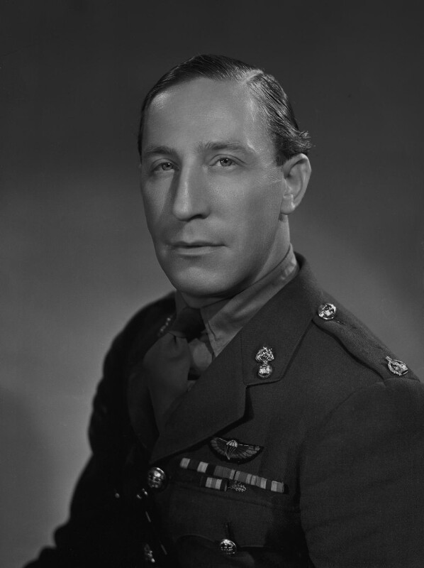
REED, Frank Percy, 658595 RAF
RILEY IRVING, Julian Eyre Lieut Royal Artillery
ROBINSON, Robert Bertram 13066572 Pioneer Corps (1918-1998) Field View Fore St Eastcote, Pinner, MDX
ROGERS, Frederick Sidney (1907-1977) Cringles, The Cross
ROOK, Arthur William 1303064 Royal Engineers (1917-1939)
ROSE, Marjorie Wrens (1919-?)
ROSE, Travers Lionel Captain 258050, Essex Regiment KIA 15 Jan 1945, Burma. Buried Rangoon, Yangon Region, Burma, commemorated Wivenhoe War Memorial.
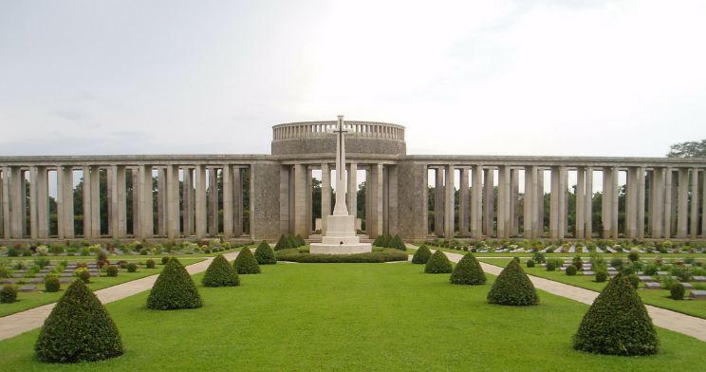
RUTT, Thomas 2147620 Military Police
SADLER, John Leonard 6012746 Essex Regt (1920-?)
SAWERS, Francis B CK/118772 Ajax (1916-1990) Belle Vue Rd
SAWERS, Francis Robert 546909 RAF (1920-2002) Manor Rd
SAWERS, Harry 1198549 RAF (1906-1982) Manor Rd
SCOFIELD, Bernard George 618450 RAF (1917-1998) Roburn, Ernest Rd
SCOTT, Eric James 6024114 Military Police (1916-1973) Elmstead Rd
SCUTT, Edward Charles (1922-1990) London House
SEADEN, John George 409258 Radio (1898-1976) Ravenscraig, Belle Vue Rd
SIMONS, Frank 13105799 Pioneer Corps (1901-?) School House, High St
SMITH, Donald Victor 14903118 RASC (?-?)
SMITH, Eileen W/2009598 WAAF
SMITH, Madge 2147802 WAAF (?-?)
SMITH, Walter 6025373 Essex Regt (?-?)
SMITH, William Cade 506101 HMS Sober Island (?-?)
SOUTHGATE, Herbert RAF
SPARLING, Alfred John 568222 RAF (1919-?) Baden, Belle Vue Rd
SPARLING, James Arthur Eng Off MV Potare (1917-2006) Baden, Belle Vue Rd
TAYLOR , Charles Frederick 2160259 ACC (1922-2011) Stanley Rd
TAYLOR , Hilda W/31056 ATS (1921-1994) Station Rd
THOMPSON, William Francis 55583 RAF (1914-?) Ernest Rd
TILLING, Kenneth John 1332424 RAF (1922-1999) The Gables, Anchor Hill
TRAYLER, Joseph 1190658 RAF (1912-1969) High St
TRICKER, Albert Edgar 13033742 Pioneer Corps (1914-1990)
TURNER, Charles A 907535 RAF (1920-?)
TURNER, Cyril Roger CM690018 HMS Monck (1921-1953)
TURNER, Henry James Ernest (1880-1951) Brooklyn Road, Dovercourt
TURNER, Sidney James (1889-?) Maldon Rd
VESSIE, Lorna Peggy 43717 Wrens (1923-2005) The Gardens, Elmstead Rd
VINCE, Ernest George 203716 HMS Europa (1911-2004) Westward, Hamilton Road
VINCE, George Arthur 105272 Landing Craft (1919-?)
VINCE, Mildred Beryl 443746 WAAF (1920-?)
VINCE, Muriel Helena W/49590 Wrens (1914-2008) Westward, Hamilton Road
WAITE, Dennis Arthur 7910035 RAC (1915-1955) The Avenue
WAITE, John Roberts 1521750 RAF (1922-2004) The Avenue
WAITE, Olive W/68306 ATS (1920-2000) Manor Rd
WARREN, Ernest Frank 2725346 2nd SAS (1926-?)
WARREN, Evelyn M (1918-?)
WARREN, Frank Leslie 10679058 RE (1921-2004) 3a The Cross
WARREN, Gordon 14374644 RASC (1924-?)
WARREN, Reginald 9**540 RHA (1920-2009) 4 Rectory Rd
WATTS, James Thomas, Lance Bombadier 5880971, 95 Bty 48 Lt AA Regt Royal Artillery, KIA 15 Jan 1945. Buried Labuan War Cemetery, commemorated Wivenhoe War Memorial.
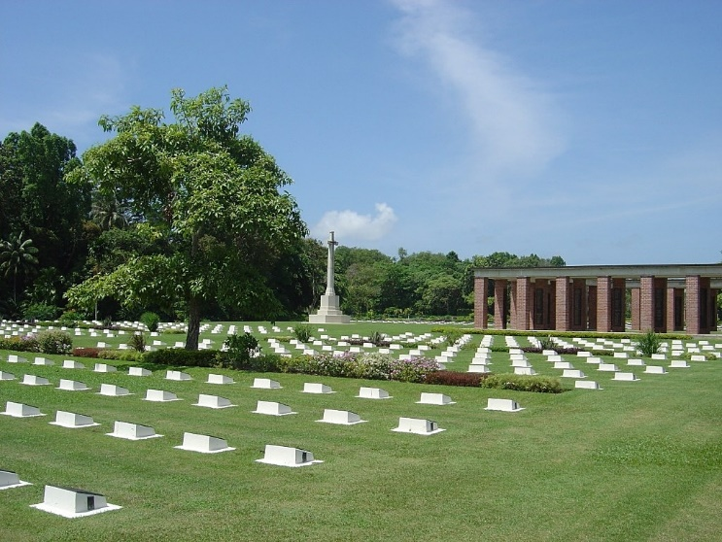

WEBB, Frank E 14873230 Pioneer Corps (1926-1994) The Folly
WEBB, Jack C Lt 109135 HMMV 1522 (1924-1985) The Folly
WELCH, Frederick 5825856 Royal Signals (1915-?
WELHAM, Nathaniel 152587 Naval Base Lowestoft (1922-1988) Wickham Rd, Colchester
WELHAM, Philip 266084 RASC (1921-1984)
WENT, George Arthur T/89581 RASC (1908-1966) Malting Yard
WHALEY, Archibald 14391925 RASC (1924-?)
WHALEY, Gilbert 196845 RASC (1920-2006) Brummel High St
WHYTE, Geoffrey James HMS Searcher (1923-2011) Isonyo, The Avenue
WHYTE, Ronald Thomas 7687628 Military Police (1915-1985) Isonyo, The Avenue
WHYTE, Thomas Norman Lt Com HMS Searcher (1918-2005) Isonyo, The Avenue
WILLIAMSON, Francis L 7596800 REME (1921-1990) Manor Rd
WILLIAMSON, Wilfred 839877 R Engineers (1917-1968) High St, Greenhithe, Kent and Manor Road
WIX, Harvey John 8/m 2402 RN (1882-1955) Swin View, Anglesea Rd
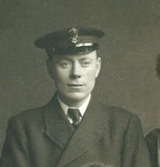
WIX, Robert Alfred 132767 HMS Smiter (1912-1995) Laceys Lane, Exning, Newmarket
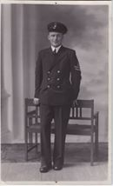
WIX, Walter William 80135 HMS President (1921-2006) Swin View, Anglesea Rd
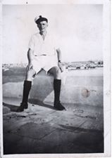
WOODS, William Arthur 635348 RAF (1900-1974) Elmstead Rd
WOODS, William James 1592931 RASC (1915-1987) East St
WOODWARD, Charles Arthur 190262 Royal Signals (1915-1991) High St
WOODWARD, Clarence F 87382 HMS Europa (1909-1987) The Quay
WRIGHT, Leslie Edwin Charles 113100 Royal Marines (1909-1992)
Photo Credits
Girl walking on wall, Station Road & USAAF Airman with children Sailing Club yard: IWM, images by Robert Sand, 55th Fighter Group, USAAF.
Churchill at Wivenhoe Park, Peter Pawsey, VE Day Street Parties and Certificate of Appreciation: Wivenhoe Memories Collection.
Welcome Home slip & Headstones in New Cemetery: Michael Smither
War Cemeteries: CWGC
POWER, Peter: National Portrait Gallery
ABLITT, Dennis Arthur: Graham Wadley Wivenhoe Memories Group, Facebook
BARTON, Leonard: Linda Panton, Wivenhoe Memories Group, Facebook
LEE, Doris Evelyn: Stephen Lee, Wivenhoe Memories Group, Facebook
LEE, William George: Stephen Lee, Wivenhoe Memories Group, Facebook
MAWDSLEY, Basil Edward: Susan Vascetta, Wivenhoe Memories Group, Facebook
MAWDSLEY, Dorothy: Donna Hoggard Marsh, Wivenhoe Memories Group, Facebook
WIX, Robert Alfred: Graham Wadley, Wivenhoe Memories Group, Facebook
WIX, Harvey John: Hilary Wadley, Wivenhoe Memories Group, Facebook

