ROAD TRAFFIC REGULATION ACT 1984 – SECTION 14(2)

Temporary Closure of Footpath 14, Wivenhoe, Colchester

NOTICE IS HEREBY GIVEN that from the date specified below, the Essex County Council has temporarily closed to all traffic under Section 14(2) of the Road Traffic Regulation Act 1984, as amended, Footpath 14, Wivenhoe in the Borough of Colchester, Footpath 14 from the point where it meets Keelers Lane to a point approximately 330 metres west of Keelers Lane where Footpath 14 meets the internal road at Wivenhoe Quarry.

The closure is scheduled to take place on 16/08/2021 for 21 days and is required for the safety of the public while works are carried out to repair flooding of the footpath from the quarry.

Alternative route will be via the internal haul road at Wivenhoe Quarry which runs parallel to the section of footpath 14 that is affected.
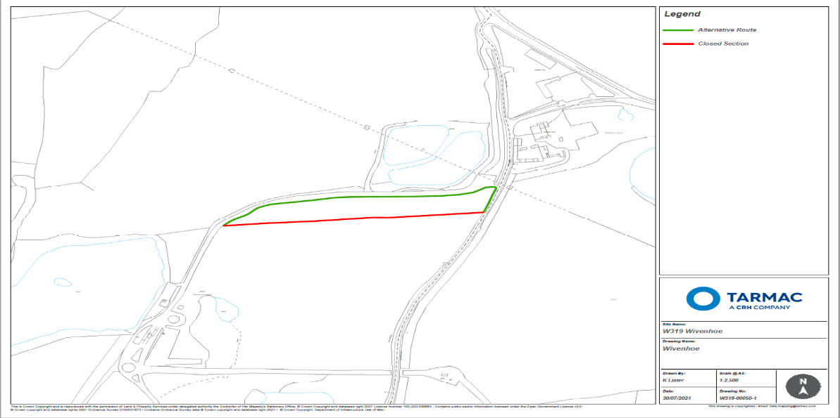

ESSEX COUNTY COUNCIL
COUNTY HALL
CHELMSFORD, ESSEX

CM1 1QH

TEL: 0345 603 7631

DATE: 16/08/2021

