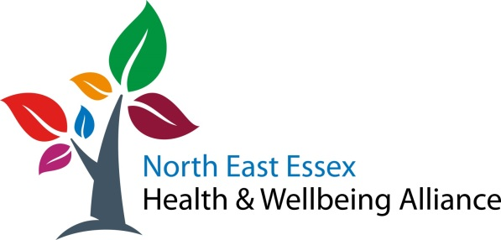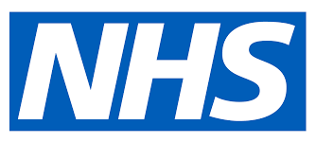
The Vaccination Bus is coming to you!
The bus will be at William Loveless Hall in Wivenhoe
Between 10am and 3pm on Tuesday the 19th of October
Delivering the Pfizer vaccine for 1st and 2nd doses
(*Must be an 8 week gap between 1st and 2nd dose)
3rd dose Boosters are also available for people aged 18 – 49 who are clinically extremely vulnerable and anyone aged 50+ (*must be 6 months gap since 2nd dose)
No appointment needed – walk in service

