WIVENHOE TOWN COUNCIL
MINUTES of Environment Committee meeting held on 14 July 2021 at 7.30pm (Chair Approved)

Present: Cllr Evans (Chair), Cllr Maltby, Cllr Wenaden, Cllr Multon, Cllr Kane, Cllr Burke and J Beighton-Emms (Town Clerk)

Public questions; None

PART A

E/07.21/01 Apologies for absence; Cllr Luxford-Vaughan and Cllr Boughton

E/07.21/02 Declarations of interest; None

E/07.21/03 Minutes of the meeting held on 5 May 2021; The minutes of this meeting were proposed by Cllr Maltby, seconded by Cllr Wenaden and approved by all as an accurate record of proceedings.

It was agreed that the Town Clerk will make enquiries regarding access rights to and
any covenants on Smith’s Corner.

E/07.21/04 Update from the Chair; Cllr Evans reported that he has been working with Terry Garland on the Ferry Marsh sluice issue by chasing up where the responsibility for the area lies and also looking at alternative options, such as a wind pump which would cost in the region of £30,000. There is a need to get the balance right between nature and the need for the pathway to remain open. A sluice is not the best option. Cllr Evans suggested that if we want organisations to get involved, such as the RSPB, the area would need to be accessible. Options need to be considered to eliminate the risk of flooding and boardwalks could be installed. This issue is likely to continue as the sluice is silted up. Cllr Evans will liaise with ECC Cllr Cory.

E/07.21/05 Report on the Green Verges Project;

The councillors considered a previously circulated report from Mark Halladay, which is
attached as Appendix A.

Cllr Evans confirmed that the project will be expanded next year and that all feedback is
being considered. Contact is being made with residents who have genuine
concerns. The councillors considered options to gather further feedback and the need
to cut back and when this would be. Cllr Evans said that a presentation will be given
to other councils and that this will be led by Steve Collis, CBC.

E/07.21/06 Proposal by Cllr Evans; To appoint non-councillors to the committee.

The councillors considered the option to formally appoint lay members to this committee but agreed that this could be done at a later date if necessary.

E/07.21/07 Proposal by Cllr Evans: To replace a section of KGV fencing with hedging.

It was agreed that Cllr Evans would meet with Jim Young to discuss the hedging. He
suggested gorse or broom. We could consider bushes from CBC from their next ‘tree
giveaway’ although these tend to be small- the fence could be left in place until they
grow. Cllr Evans will report back on the best options

E/07.21/08 Proposal by Cllr Evans: To create an orchard on the land known as Smith’s

Corner, subject to permissions and any covenants.

It was agreed that Cllr Evans would meet with Jim Young to discuss the best options of
trees for planting and when to plant.

Cllr Maltby requested that the councillors discuss the climate action plan and WTC’s
commitment to be carbon neutral by 2030. One of her action points is to contact
Brightlingsea Town Council and also for an energy assessment to be done on WTC’s
properties.

The Town Clerk confirmed that the Office & Yard Working Group are looking at
energy options when the offices are redeveloped. Cllr Burke said that we should be
looking at electric car charging points. Cllr Maltby reported that she was reviewing what
Arlesford PC are doing to install them. The Town Clerk said that WTC needs to know
about how they are managed and any costs.

E/07.21/09 Health & Wellbeing Update: Report from Cllr Wenaden.

Cllr Wenaden reported that a date had been agreed for an event on the KGV. Also, that
the Essex Rebels would like to start a mid-week basketball club in the WLH. Cllr
Wenaden has been in contact with CBC Cllr Burrows regarding a number of her
Initiatives, including free sessions with the Microgym. Cllr Wenaden hopes to
promote referrals from the GP to some of the groups. She also suggested a bird talk by
Cllr Evans at Stuart Pawsey Court and would like to have a 12 month plan.

Cllr Burke suggested an initiative to create intergenerational groups and also more
reaching out to those who are lonely. Cllr Evans suggested contact with established
local groups such as Helping Hands.

Cllr Evans asked Cllr Wenaden to make a list of all of the ideas. Cllr Wenaden left the
meeting.

Cllr Maltby asked if Transition Town Wivenhoe could use one of the garages in the
yard. The Town Clerk will make enquiries.

E/07.21/10 Date and time of the next meeting; It was agreed that the next meeting would

be held at 7.30pm on Wednesday 1 September 2021.

The Chair closed the meeting at 21.12.

Appendix A

Bi monthly report of the green spaces project

At its meeting in January WTC agreed to trial conservation-based “no mow” management regimes at a number of green spaces in the town. This report summarises progress on those sites since the May Environment Committee and asks the Committee to authorise two related initiatives as follows:

- Part of Smiths Corner has been identified as a site for a community orchard. CBC have been approached for support in supplying trees. Maintenance would be by the Town Council’s staff and volunteers (Smiths Corner is a WTC responsibility). If it is a success, there are other green spaces in the town which might also be suitable for further community orchards.
- The fence at the north (top) end of the KGV needs replacing. It is proposed to plant a hedge along the fence line with hedging subject to a suitable supply of plants being available.

The Committee is asked to approve these initiatives to be taken forward by the WTC estates team.

Progress on the Green Spaces project

8 local residents have joined the project as volunteers. They are responsible for surveying the sites. CBC have erected information boards at all sites and Jim holds a supply of spares.

Mowing effectiveness: No problems with mowing. Some concerns from residents about the general length of grass around the town due to the explosive Spring growth resulting from the rain and late spring. Sight line concerns raised and addressed at Broadfields and Cracknell Close.

Survey results: 67 different species of wildflower were found to be in flower across the 15 sites during the last week in May.
The first comparison count of mown and unmown areas found that there were on average 5 times as many flowers in the unmown compared to the mown sites.

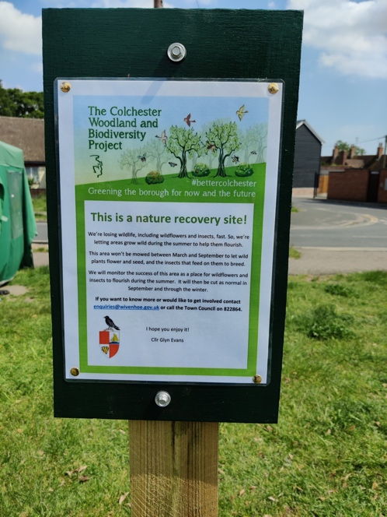

Public response to date

60 letters to neighbours of the project sites have been sent. Only one response was received. This supported the initiative and explained that they needed no mowing of the pathway from their back gate (de Vere Close resident).

Updates on the project have been posted on the Town Council and Wivenhoe Community Facebook pages. Members of the public have also posted about aspects of the project. The comments which the posts have attracted have been overwhelmingly supportive.

Date, location & person posting | Substance of initial post | Response to initial post
12/3, WTC page, Glyn | Launch and description of the project | 32 “likes”, 9 comments, all supportive
9/5, WivComm page, Mark | Update on the project and results of March & April surveys | 156 “likes”, 33 comments, all but one supportive
29/5, WivComm page, member of public | Regret that Millfields was cut when it was full of flowers at the end of May | 16 “likes”, 15 mostly supportive comments
7/6, WivComm page, Mark | Update on the project and advice about mowing lawns for best biodiversity impact. | 149 “likes”, 53 comments, most very supportive.
16/6, WivComm, member of public | Concern that unmowed sites are making his hay fever worse. | 18 “likes”, 61 comments, most from fellow hayfever sufferers debunking the idea.

While the vast majority of comments have been simple statements of support, some important issues have also been raised and resolved. The substance and responses to these comments are summarised below.

Issues raised in comments | Project response to comments
That residents should be encouraged to support wildlife in their own gardens. | Acknowledged as an aim of the project – to encourage similar wild life support at home.
Offer of help from resident | Invite to get in touch. No response.
Request that the update include advice against using herbicides in gardens (2 similar comments in separate posts) | Future update will do so. Another member of the public suggested they might do an article for WivNews on the perils of herbicides.
That the area (Millfields) is a multi-use site; | clarified who was responsible for Millfields and that it is cut for multi-use
invited people to join in. | 1 new volunteer recruited.
scepticism at the project surveys | Explained how the surveys work.
suggestion that wildflower sowing would better | Explained that might follow where natural regeneration doesn’t increase biodiversity.
Sight lines at Broadfields need improving. | Sight lines at Broadfields widened.
long grass makes it hard to pick up dog mess | No comment on dog issue.
complaints about long grass on non project sites. | clarified which sites are in the project and which are simply long due to heavy Spring growth.
pesticides should be banned (2 comments) | Expressed support for pesticides ban.
Sight lines at Cracknell Close need cutting. | Sight lines at Cracknell being reviewed with contractor.
suggestion for “edible verges” I.e. using verges to grow veg. | No comment made.

Survey volunteers have been approached by 11 members of the public while doing site surveys. All 11 expressed support for the project, one offering to sow wildflower seed on the site (offer declined) and another wanting to join in the surveys with her small children.

CBC has reported only one complaint about the project sites since the beginning of the project. This was another statement of concern about the sight lines at Broadfields. In addition Cllr Evans received one direct message about long grass at a site not in the project.

Conclusion: the project seems to be well supported by people and is attracting constructive comment on how it can be improved at specific sites.

